**School of Computers and Information Engineering**

**STUDENT LEARNING ACTIVITY**

Fall Semester 2019

**Application Programming in Java (SOC 2030)**

­­­­­­­­­­

Library Management System(LMS)

Student Learning Assignment

**Instructor:** Dr. Sarvar Abdullaev **Email:** s.abdullaev@inha.uz

Submitted by

U1810266, Jonibek Mansurov (Group#006)

U1810281, Amir Djanibekov (Group#006)

U1810256, Alisher Khasanov (Group#006)

U1810270, Aleksandr Sim (Group#006)

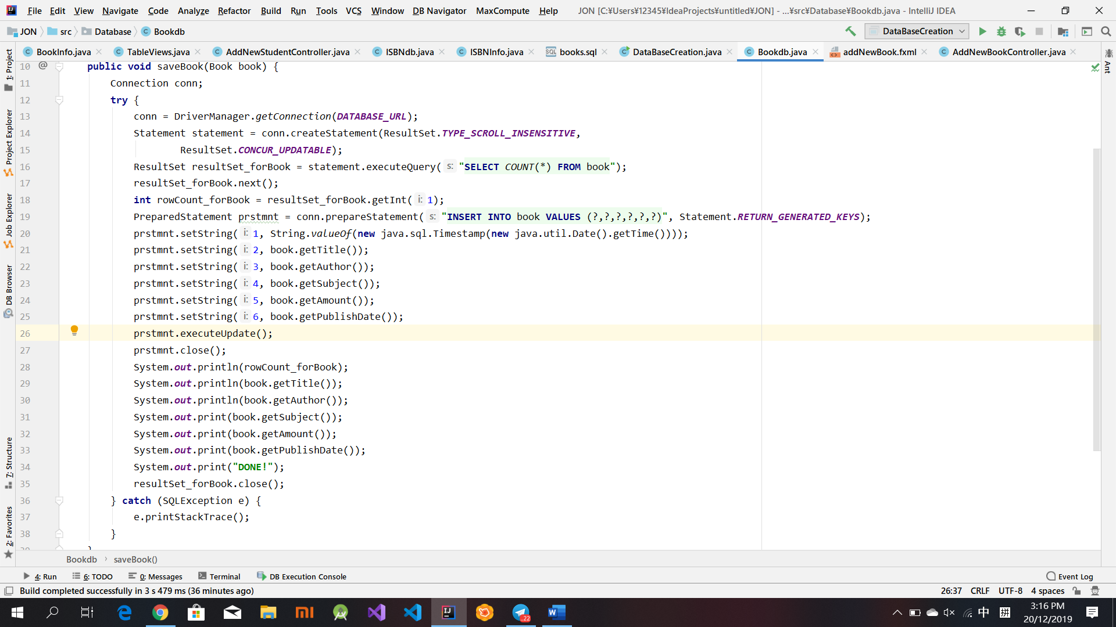

saveBook() function gets elements from class Book where elements extends from TextFields of GUI and insert into sql table. saveISBN() function in another class has same functionality.

Responsible: U1810281 Djanibekov A., U1810256 Khasanov A

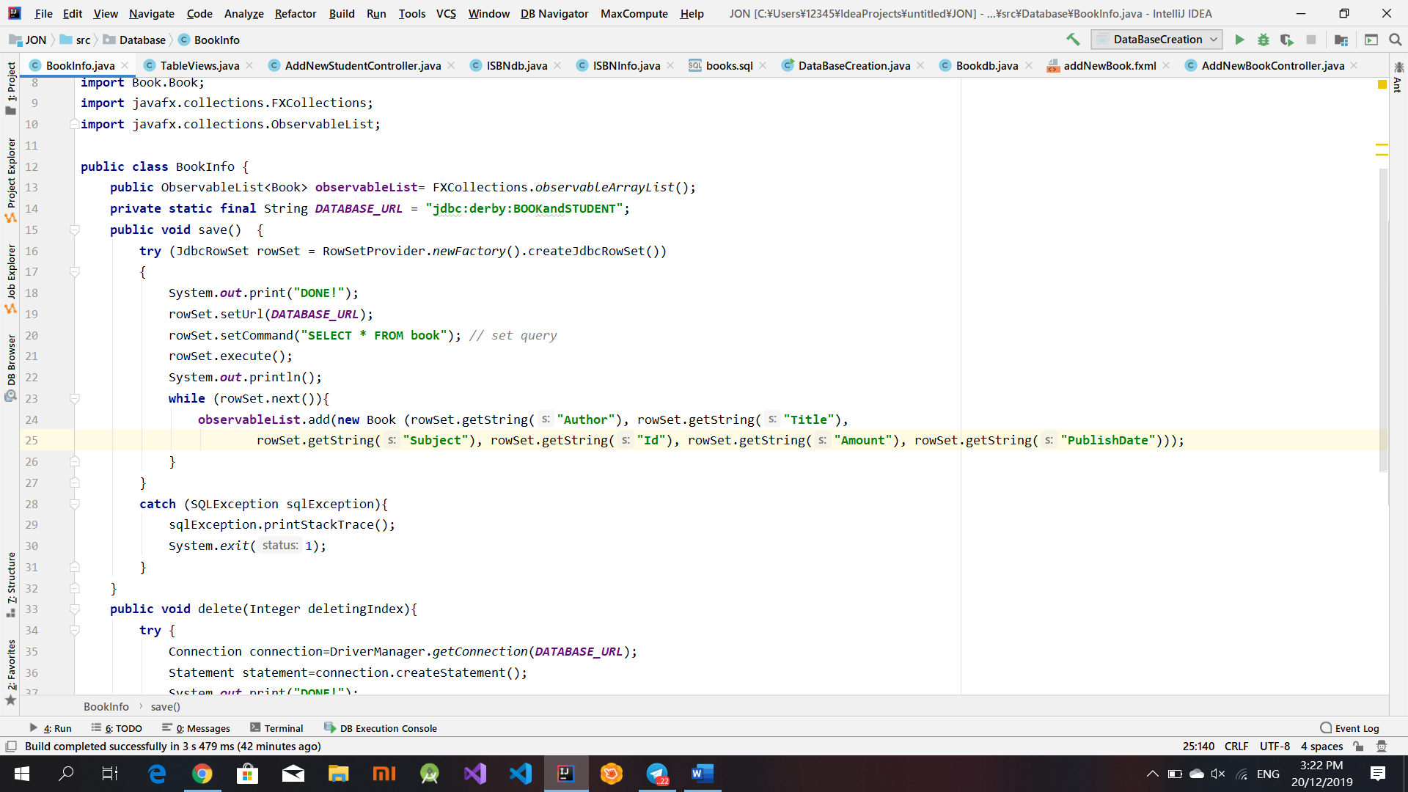

save() function copies elements from Database book table to ObserverList for upcoming usage and displaying in GUI. Same function exists for ISBN.

Responsible: U1810270 Sim A., U1810281 Djanibekov A.

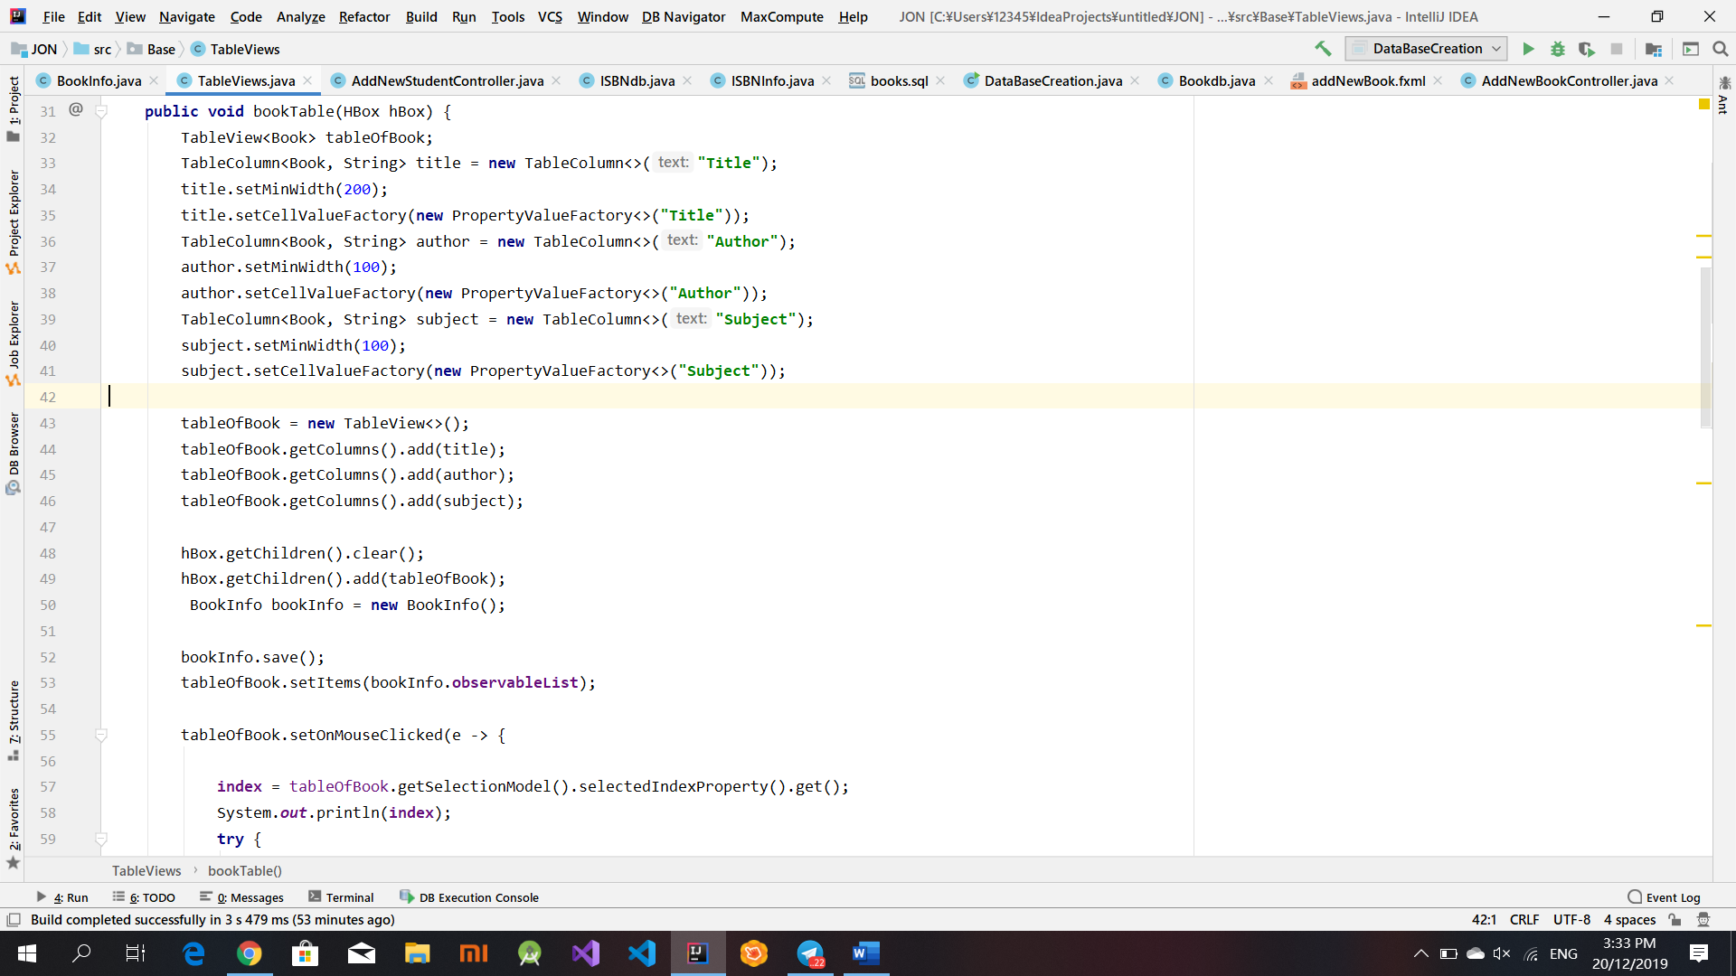

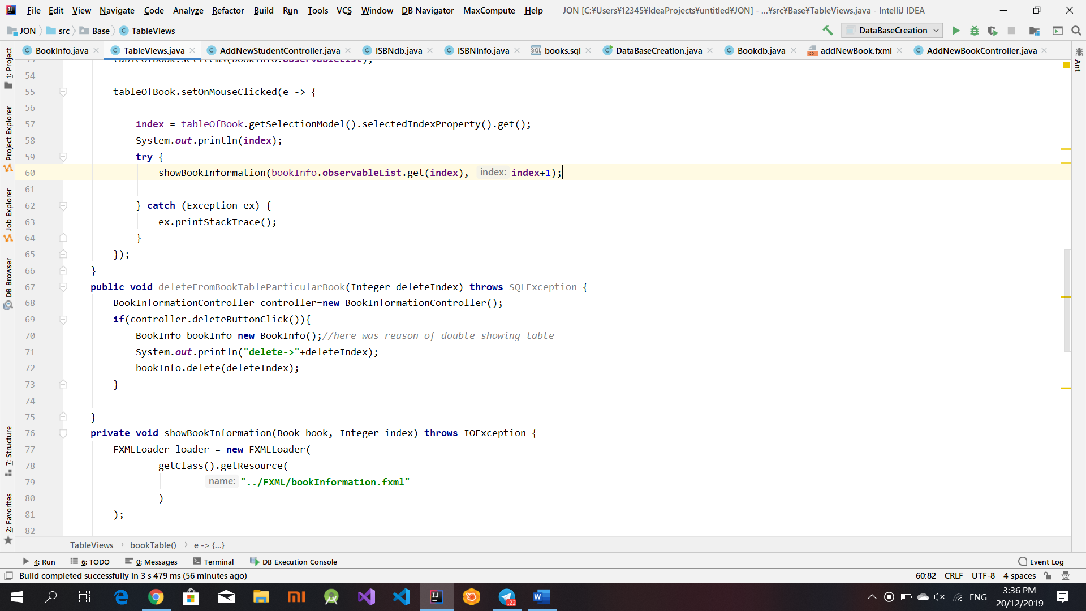

bookTable() creates table in AddministratorMenu.fxml depending on provided options, also displays observerList and provides index of clicked row in the table. All others table functions do same job.

Responsible: U1810266 Mansurov J., U1810256 Khasanov A, U1810270 Sim A

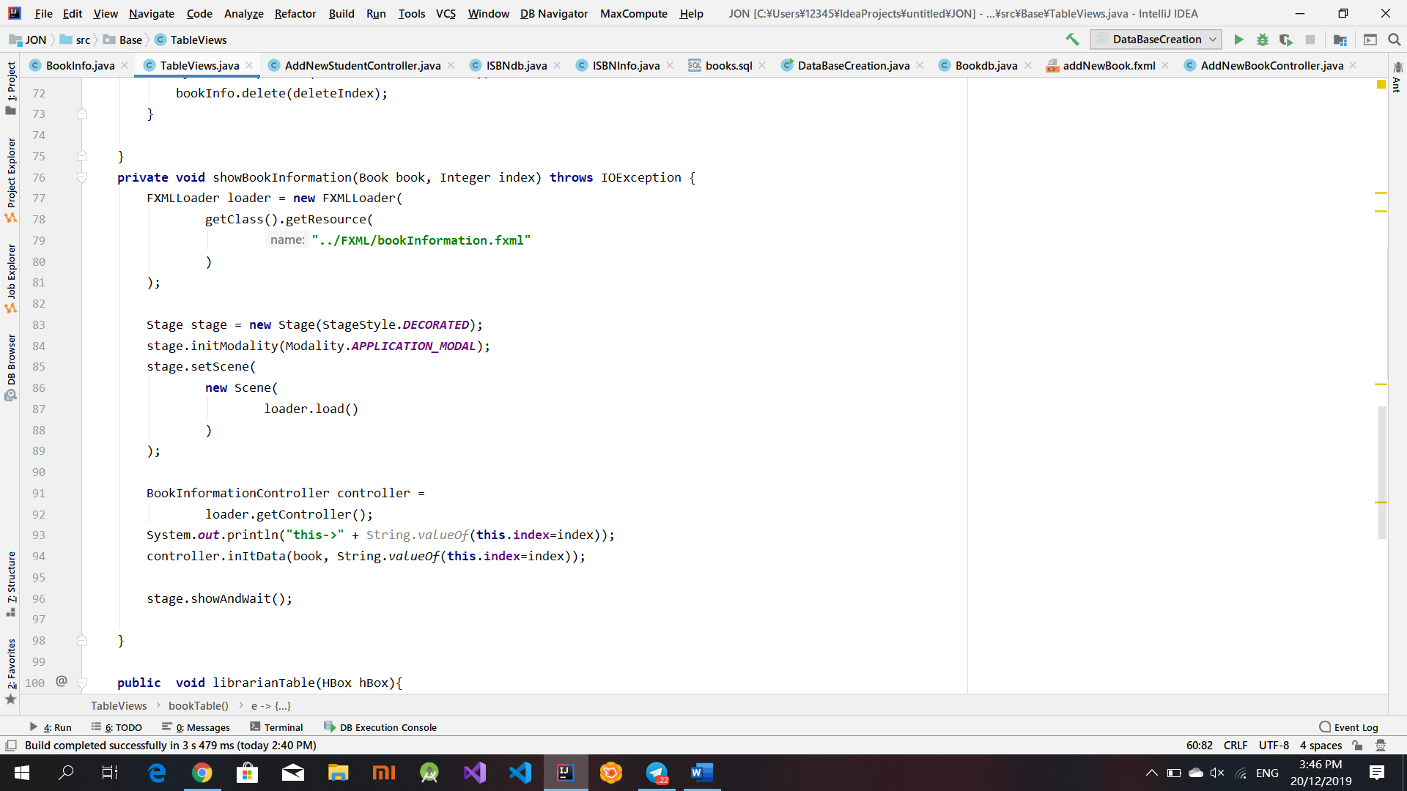howBookInformation was taken from Internet resource in order to send information about book before opening particular stage.

Responsible: U1810266 Mansurov J.

<https://issue.life/questions/14187963>

All other functions such as deleting, modifying and inserting librarian’s , student’s and book’s duties extend the same principles from mentioned functions above

**USERS ACCOUNTS:**

**ADMIN**

**login: admin**

**password: adminnumberone**

**LIBRARIAN**

**login: librarian**

**password: pythonBetter**

**STUDENT**

**login: U1810281**

**password: tyIndians4help**